**SOLUTION ARCHITECTURE**

**Design:**

* The recipient can track donor details and design portfolio
* It design industry trends and design hiring
* The location of the donor and the status of the donor can be tracked.

**Software and system required:**

* Python
* Flask
* Docker
* Kubernetes
* HTML
* Cloud
* Laptop or Desktop

**Block Diagram:**

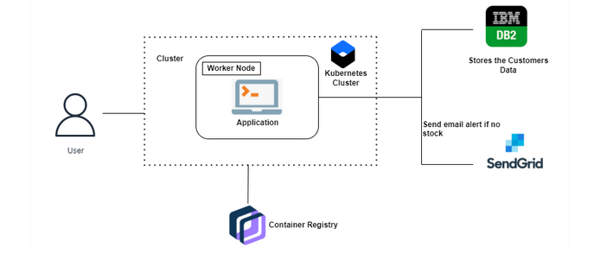

**Cloud Services:**

